**Curriculum Vitae (RESUME)**

**Last update: 10 March 2024 (1402/12/20)**

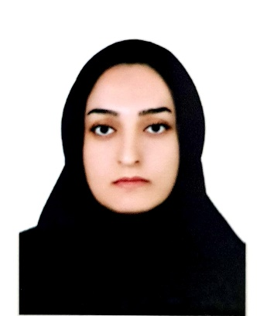

**Personal Information:**

**Name:** **Agrin**  **Surname:** **Mohammadi**

Master of Psychiatric Nursing

**Date of Birth:** **1993-08-12**

**Place of Birth:** **Marivan, IRAN**

**Nationality:** **Iranian**

**Affiliations:**

Psychiatric nurse, Instructor, Faculty of Nursing and Midwifery, Kurdistan University of Medical Sciences, Sanandaj, Iran

## **Email:** [agrinmohammady.2013@gmail.com](mailto:agrinmohammady.2013@gmail.com) & [Agrin.mohammady@muk.ac.ir](mailto:Agrin.mohammady@muk.ac.ir)

**Phone:** 00989187709226

**Education:**

|  |  |  |  |
| --- | --- | --- | --- |
| **Degree** | **University** | **Field** | **Date** |
| M.Sc. | Shiraz University of Medical Sciences | Psychiatric Nursing | 1400 (2022) |
| B.Sc. | Kurdistan University of Medical Sciences | Nursing | 1395 (2017) |

**M.Sc. Thesis**

* The Prevalence of Misophonia and Its Relationship with Obsessive-compulsive Disorder, Anxiety, and Depression in Undergraduate Students of Shiraz University of Medical Sciences: A Cross-Sectional Study.

**Employment date**

Started working as a nurse in the ICU of Tohid Hospital on 28 February 1395 to 30 September 1397 and 1 February 1399 to 11 March 1400.

From 11 March 1400 until now; as a academic member in the Nursing Department, Faculty of Nursing and Midwifery, Kurdistan University of Medical Sciences.

**Executive positions**

Faculty Accreditation Officer (16 April 1401 until now)

**Teaching experiences:**

* Work with students of psychiatry department (nursing students)
* Teaching life skills (emergency medicine students)

**Publications:**

1. Shaygan M, Tehranineshat B, Mohammadi A, Foruhi Z. A National Survey of the Prevalence of Chronic Pain in Nursing Students and the Associated Factors. Investigación y Educación en Enfermería. 2022 Apr;40(1).
2. Yektatalab S, Mohammadi A, Zarshenas L. The prevalence of Misophonia and its relationship with obsessive-compulsive disorder, anxiety, and depression in undergraduate students of Shiraz University of Medical Sciences: a cross-sectional study. International Journal of Community Based Nursing and Midwifery. 2022 Oct;10(4):259.